

UTHAI-Humanoid

**Dynamics Properties**

Version [0.0.3]

Modified: 2018/3/10

Principle authors:

Liews

## All robot

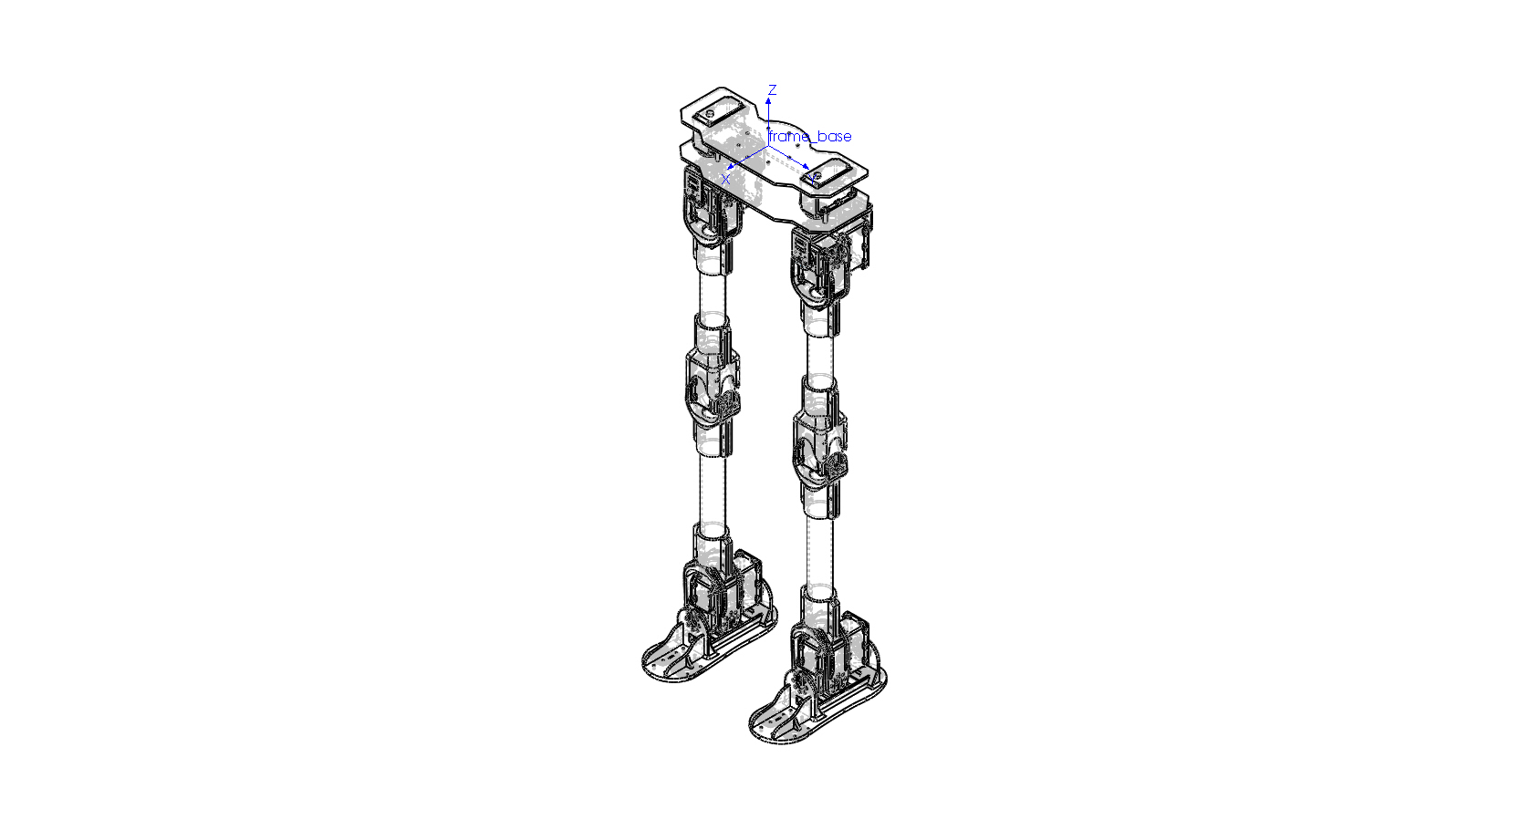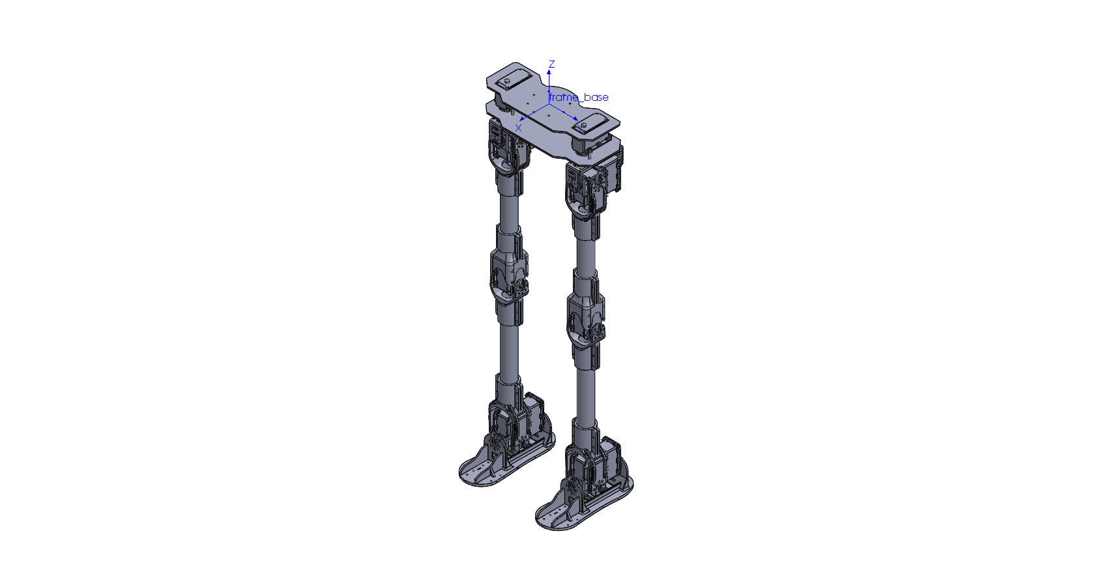

# URDF Convention

| Link | Frame | Mass [kg] | Center of mass [m] | | |
| --- | --- | --- | --- | --- | --- |
| X | Y | Z |
| All Robot | frame_base | 3.56700000 | -0.00836813 | 0.00000000 | -0.31830739 |

| Link | Moments of Inertia [kg*m^2] (Taken at the center of mass) | | | | | |
| --- | --- | --- | --- | --- | --- | --- |
| Ixx | Ixy | Ixz | Iyy | Iyz | Izz |
| All Robot | 0.31081793 | -0.00000313 | -0.00035731 | 0.28471758 | -0.00000024 | 0.03125190 |

# DH convention

| Link | Frame | Mass [kg] | Center of mass [m] | | |
| --- | --- | --- | --- | --- | --- |
| X | Y | Z |
| All Robot | frame_base | 3.56700000 | -0.00836813 | 0.00000000 | -0.31830739 |

| Link | Moments of Inertia [kg*m^2] (Taken at the center of mass) | | | | | |
| --- | --- | --- | --- | --- | --- | --- |
| Ixx | Ixy | Ixz | Iyy | Iyz | Izz |
| All Robot | 0.31081793 | -0.00000313 | -0.00035731 | 0.28471758 | -0.00000024 | 0.03125190 |

## pelvis

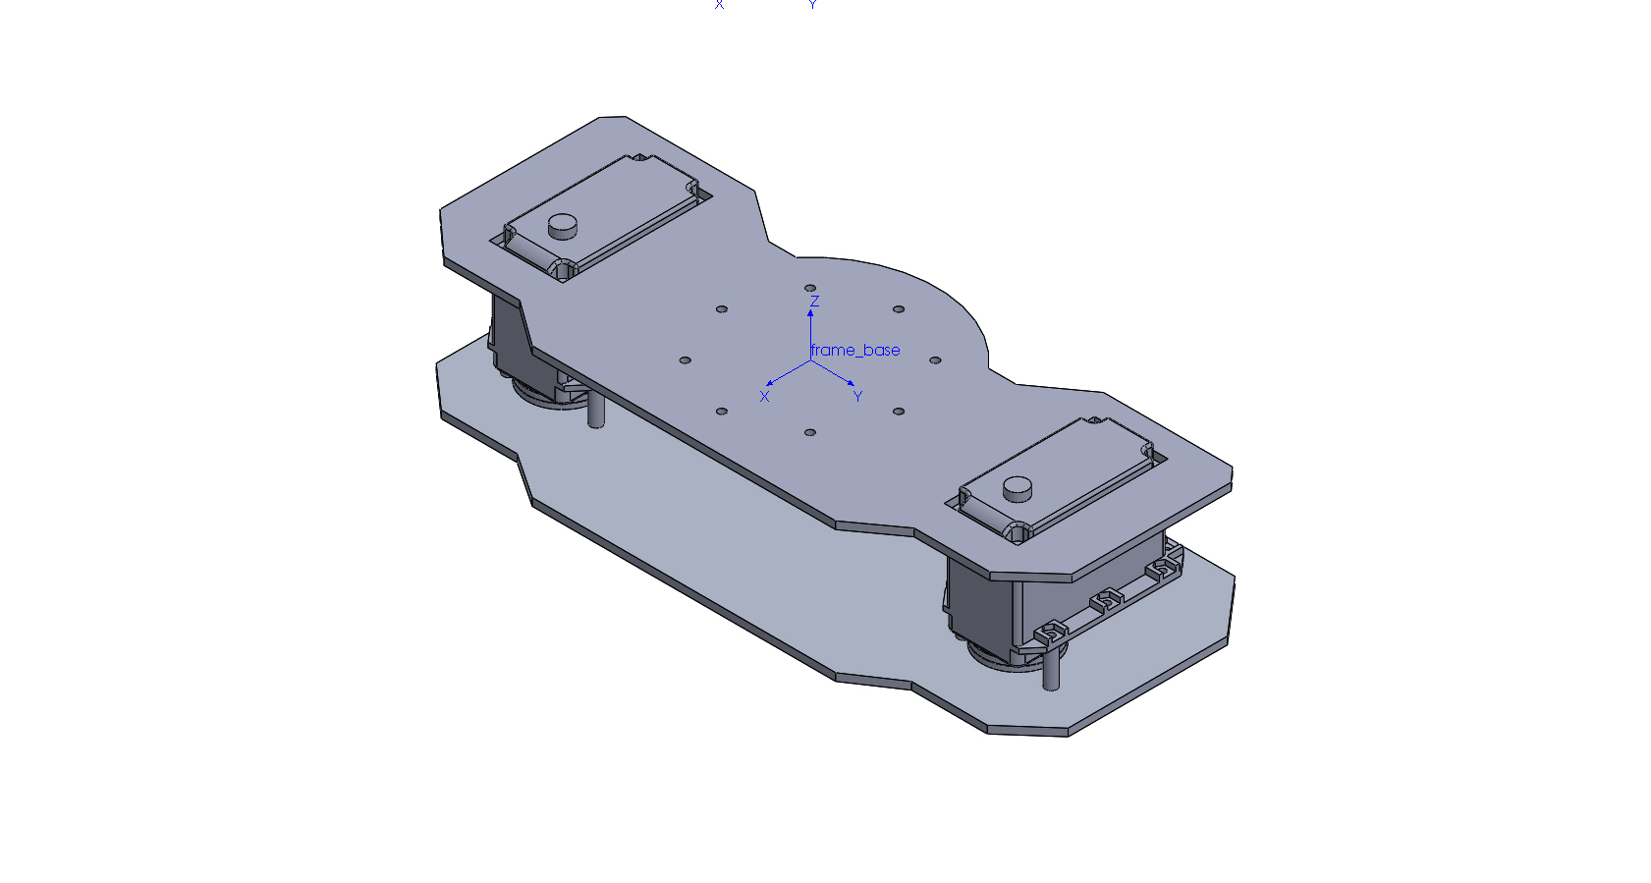

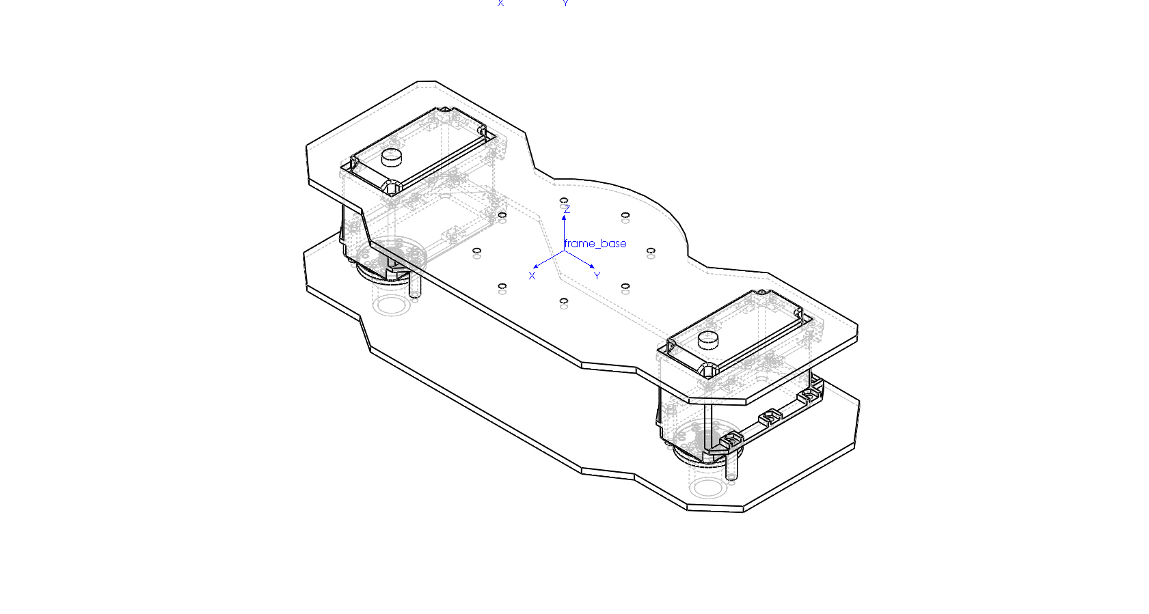

# URDF Convention

| Link | Frame | Mass [kg] | Center of mass [m] | | |
| --- | --- | --- | --- | --- | --- |
| X | Y | Z |
| Pelvis | frame_base | 0.86500000 | -0.00557436 | 0.00000000 | -0.02356598 |

| Link | Moments of Inertia [kg*m^2] (Taken at the center of mass) | | | | | |
| --- | --- | --- | --- | --- | --- | --- |
| Ixx | Ixy | Ixz | Iyy | Iyz | Izz |
| Pelvis | 0.00656431 | -0.00000003 | -0.00000466 | 0.00067608 | 0.00000000 | 0.00664141 |

# DH convention

| Link | Frame | Mass [kg] | Center of mass [m] | | |
| --- | --- | --- | --- | --- | --- |
| X | Y | Z |
| Pelvis | frame_base | 0.86500000 | -0.00557436 | 0.00000000 | -0.02356598 |

| Link | Moments of Inertia [kg*m^2] (Taken at the center of mass) | | | | | |
| --- | --- | --- | --- | --- | --- | --- |
| Ixx | Ixy | Ixz | Iyy | Iyz | Izz |
| Pelvis | 0.00656431 | -0.00000003 | -0.00000466 | 0.00067608 | 0.00000000 | 0.00664141 |

## RIGHT LEG -> Hip yaw

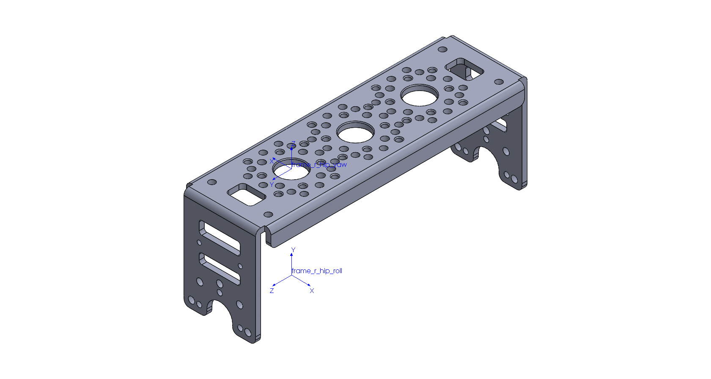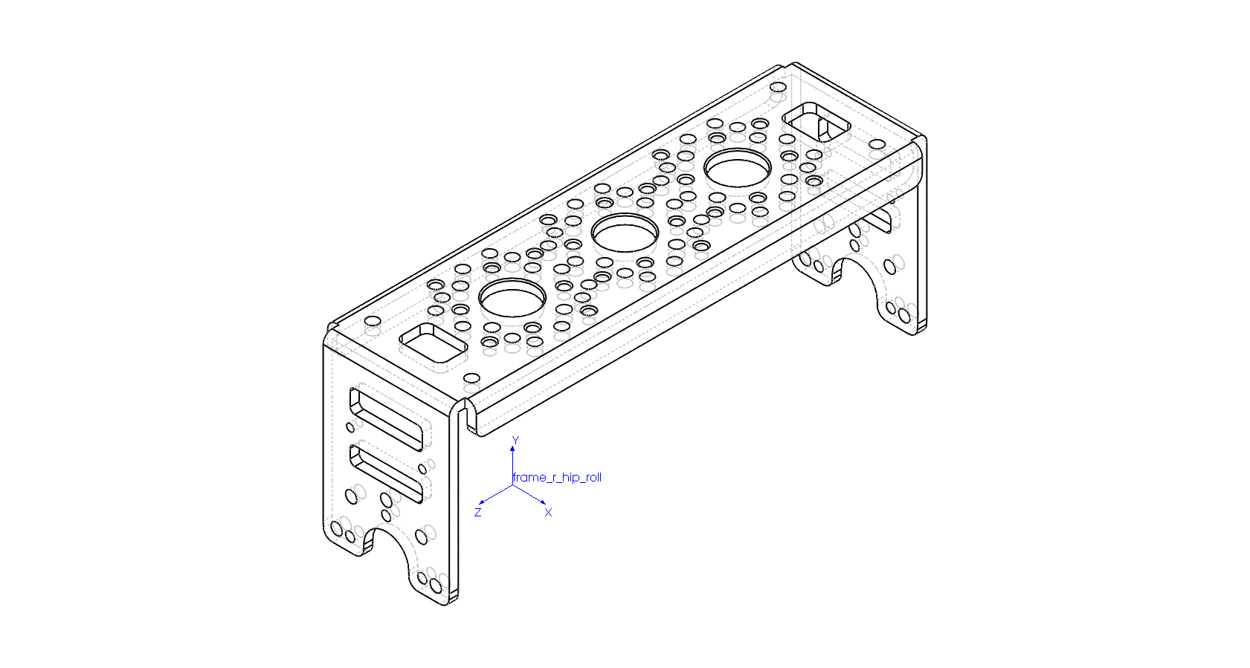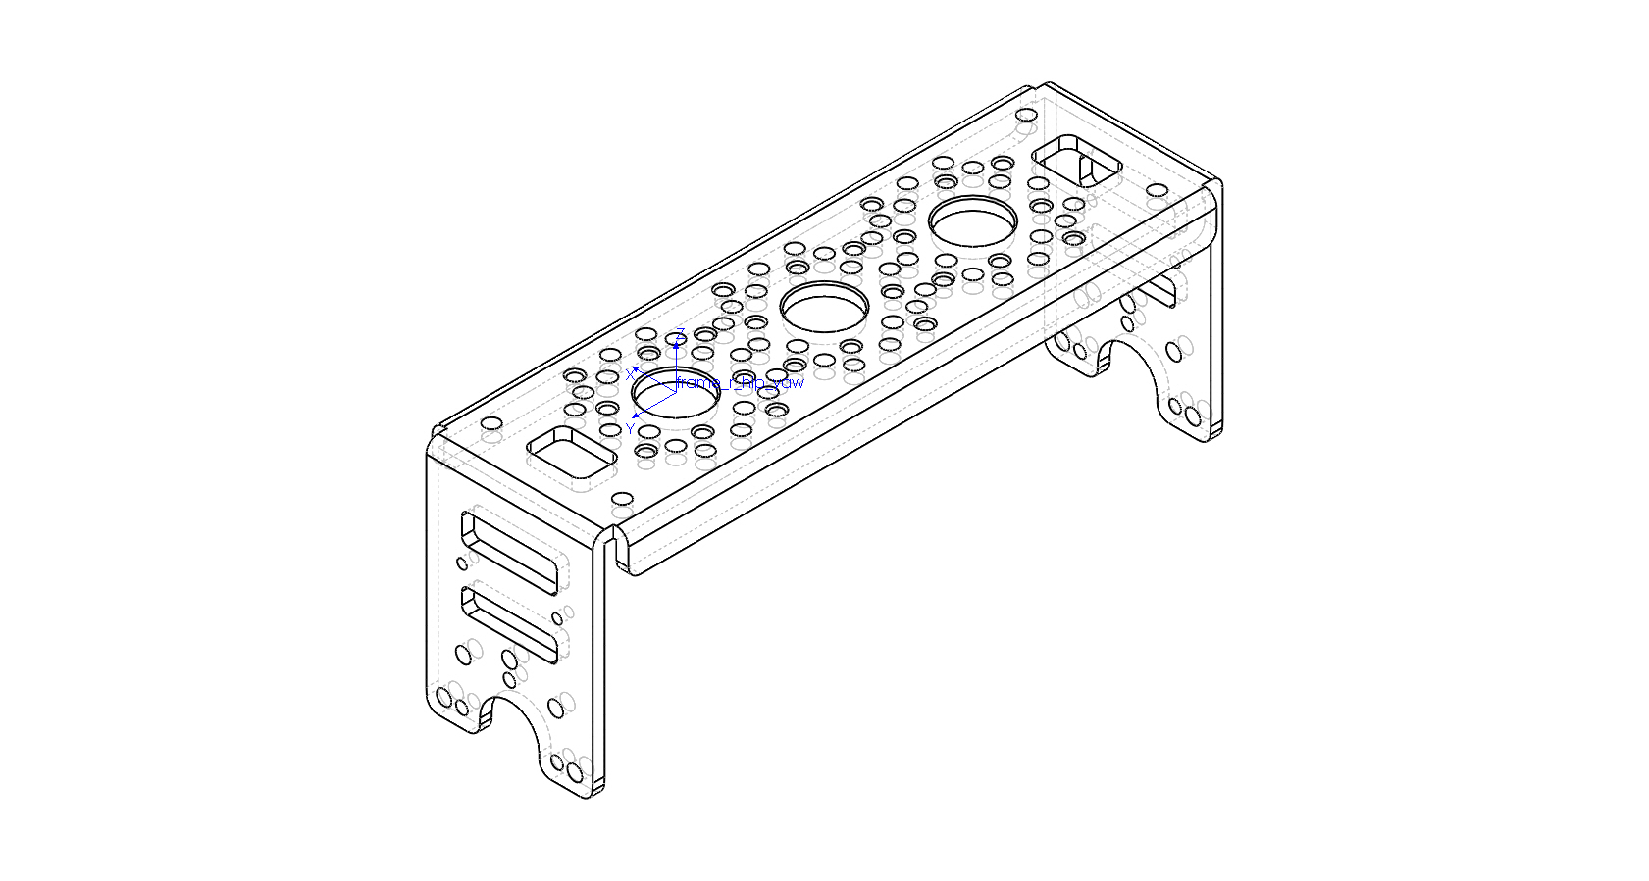

# URDF Convention

| Link | Frame | Mass [kg] | Center of mass [m] | | |
| --- | --- | --- | --- | --- | --- |
| X | Y | Z |
| R Hip Yaw | frame_r_hip_yaw | 0.09100000 | 0.00000000 | -0.02500000 | -0.00735017 |

| Link | Moments of Inertia [kg*m^2] (Taken at the center of mass) | | | | | |
| --- | --- | --- | --- | --- | --- | --- |
| Ixx | Ixy | Ixz | Iyy | Iyz | Izz |
| R Hip Yaw | 0.00014158 | 0.00000000 | 0.00000000 | 0.00002022 | 0.00000000 | 0.00014316 |

# DH convention

| Link | Frame | Mass [kg] | Center of mass [m] | | |
| --- | --- | --- | --- | --- | --- |
| X | Y | Z |
| R Hip Yaw | frame_r_hip_roll | 0.09100000 | 0.00000000 | 0.02864983 | -0.02500000 |

| Link | Moments of Inertia [kg*m^2] (Taken at the center of mass) | | | | | |
| --- | --- | --- | --- | --- | --- | --- |
| Ixx | Ixy | Ixz | Iyy | Iyz | Izz |
| R Hip Yaw | 0.00014158 | 0.00000000 | 0.00000000 | 0.00014316 | 0.00000000 | 0.00002022 |

## RIGHT LEG -> Hip roll

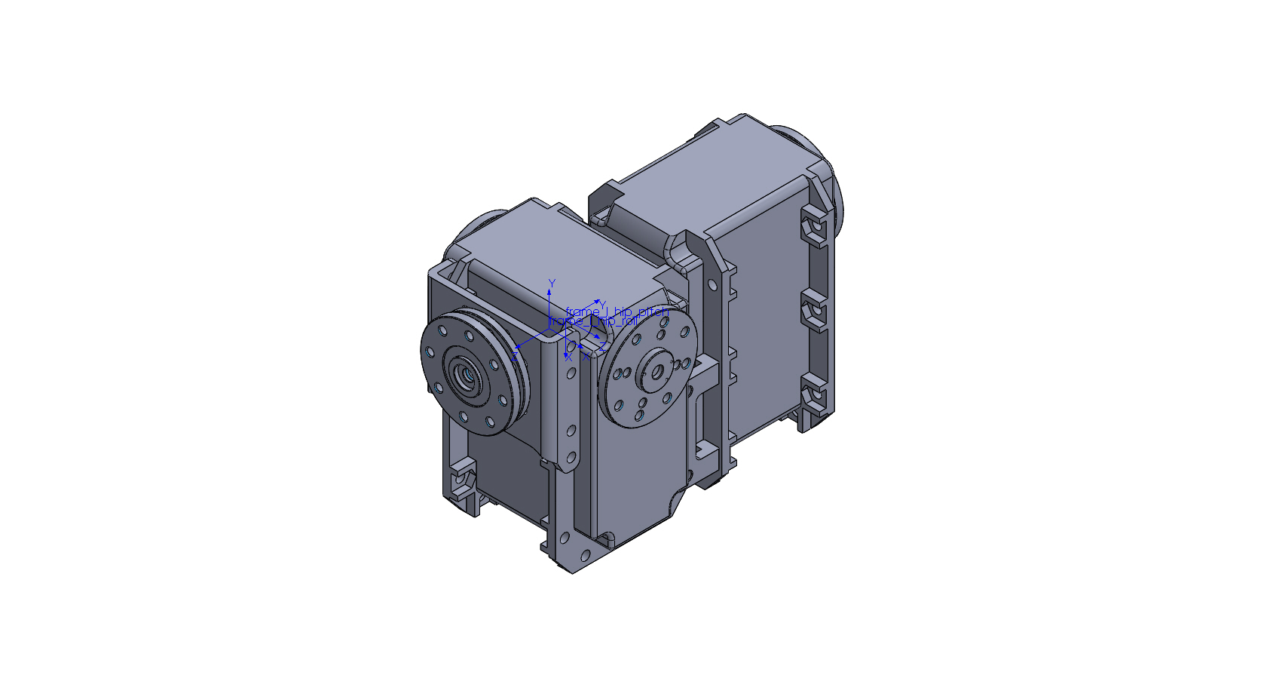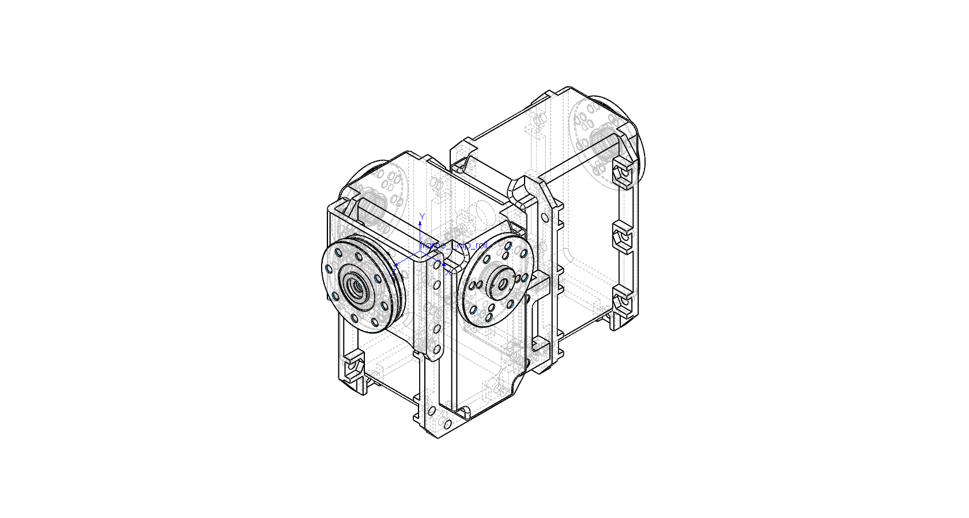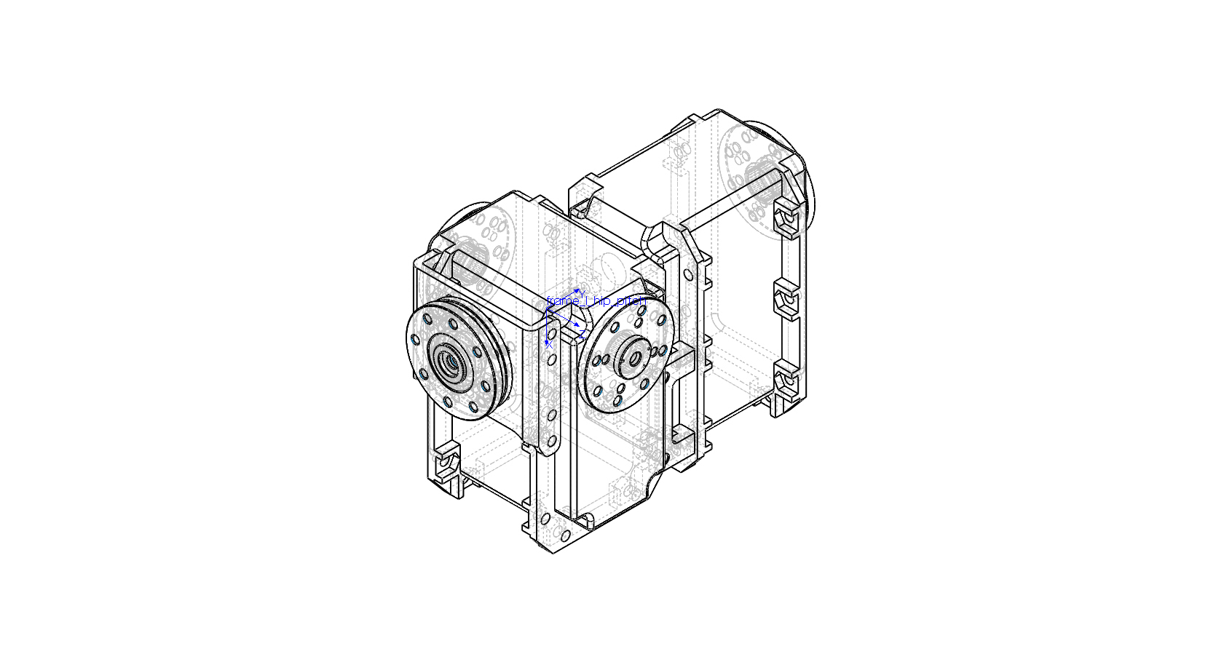

# URDF Convention

| Link | Frame | Mass [kg] | Center of mass [m] | | |
| --- | --- | --- | --- | --- | --- |
| X | Y | Z |
| R Hip Roll | frame_r_hip_roll | 0.34300000 | 0.00000000 | -0.01526210 | -0.02652545 |

| Link | Moments of Inertia [kg*m^2] (Taken at the center of mass) | | | | | |
| --- | --- | --- | --- | --- | --- | --- |
| Ixx | Ixy | Ixz | Iyy | Iyz | Izz |
| R Hip Roll | 0.00032449 | 0.00000081 | 0.00000000 | 0.00026847 | 0.00000219 | 0.00014760 |

# DH convention

| Link | Frame | Mass [kg] | Center of mass [m] | | |
| --- | --- | --- | --- | --- | --- |
| X | Y | Z |
| R Hip Roll | frame_r_hip_pitch | 0.34300000 | 0.01526210 | 0.02152545 | 0.00000000 |

| Link | Moments of Inertia [kg*m^2] (Taken at the center of mass) | | | | | |
| --- | --- | --- | --- | --- | --- | --- |
| Ixx | Ixy | Ixz | Iyy | Iyz | Izz |
| R Hip Roll | 0.00026847 | 0.00000219 | -0.00000081 | 0.00014760 | 0.00000000 | 0.00032449 |

## RIGHT LEG -> Hip pitch

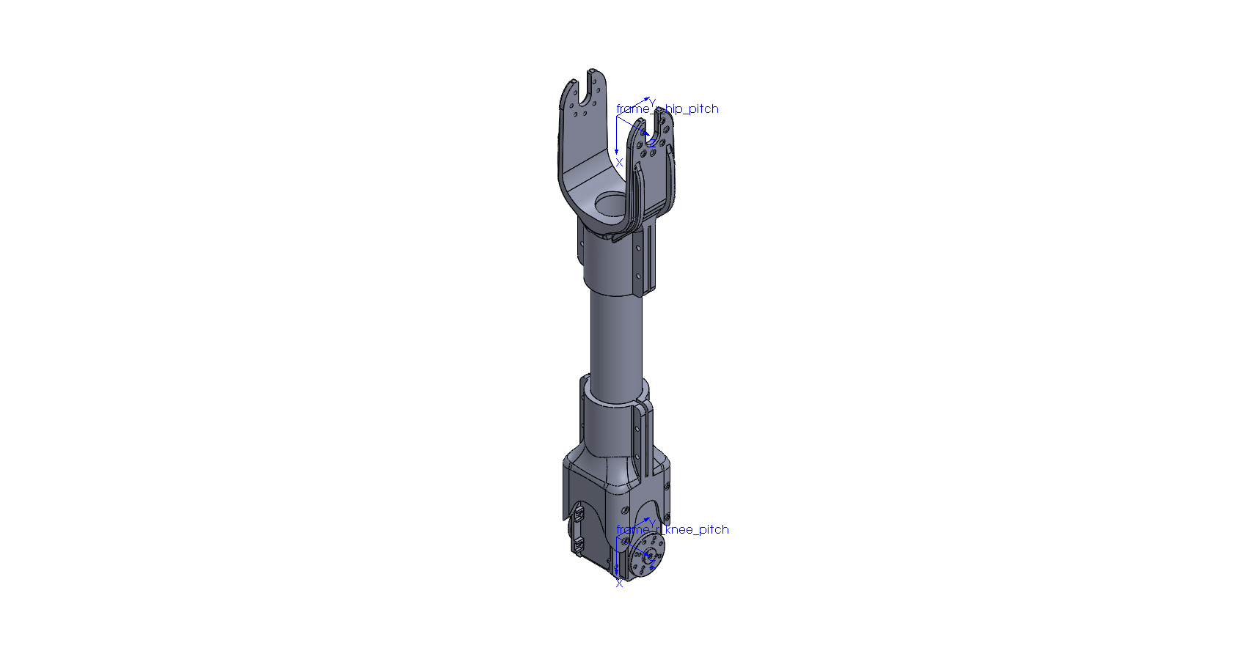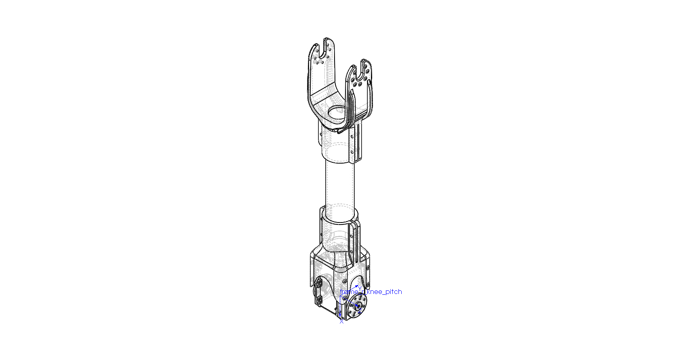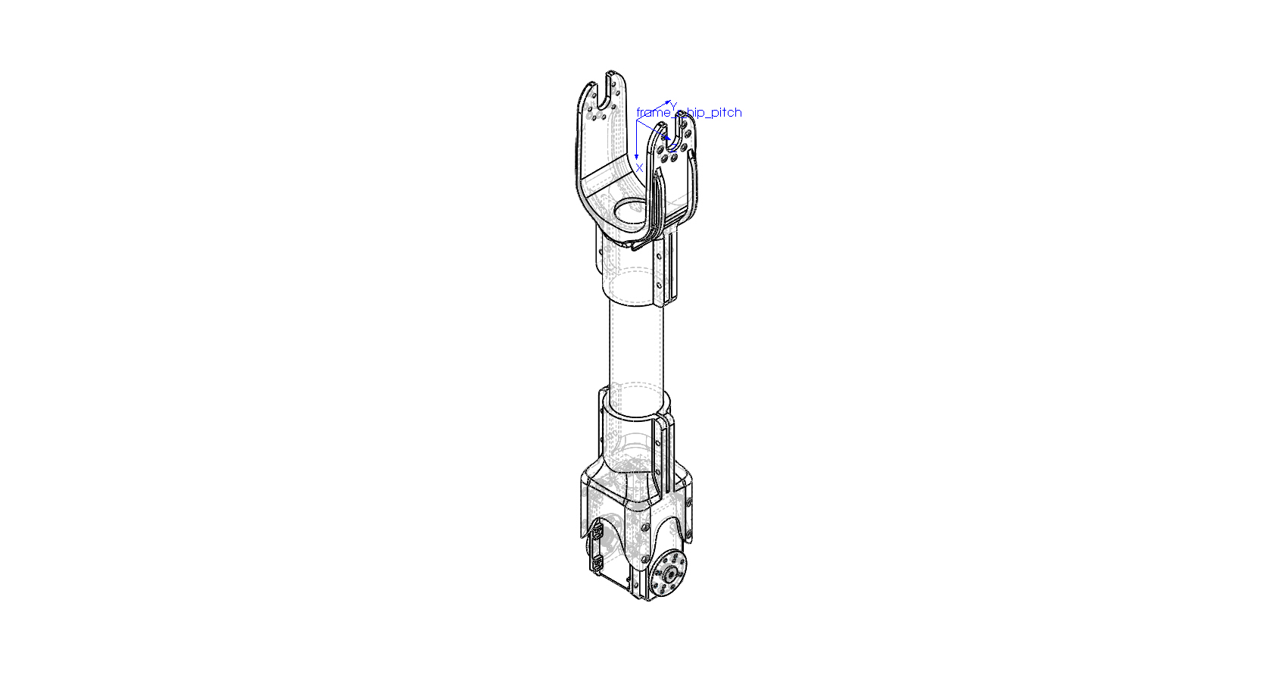

# URDF Convention

| Link | Frame | Mass [kg] | Center of mass [m] | | |
| --- | --- | --- | --- | --- | --- |
| X | Y | Z |
| R Hip Pitch | frame_r_hip_pitch | 0.31800000 | 0.22137989 | 0.00000000 | 0.00000000 |

| Link | Moments of Inertia [kg*m^2] (Taken at the center of mass) | | | | | |
| --- | --- | --- | --- | --- | --- | --- |
| Ixx | Ixy | Ixz | Iyy | Iyz | Izz |
| R Hip Pitch | 0.00011525 | 0.00000000 | 0.00000078 | 0.00254669 | 0.00000000 | 0.00250848 |

# DH convention

| Link | Frame | Mass [kg] | Center of mass [m] | | |
| --- | --- | --- | --- | --- | --- |
| X | Y | Z |
| R Hip Pitch | frame_r_knee_pitch | 0.31800000 | -0.07862011 | 0.00000000 | 0.00000000 |

| Link | Moments of Inertia [kg*m^2] (Taken at the center of mass) | | | | | |
| --- | --- | --- | --- | --- | --- | --- |
| Ixx | Ixy | Ixz | Iyy | Iyz | Izz |
| R Hip Pitch | 0.00011525 | 0.00000000 | 0.00000078 | 0.00254669 | 0.00000000 | 0.00250848 |

## RIGHT LEG -> knee pitch

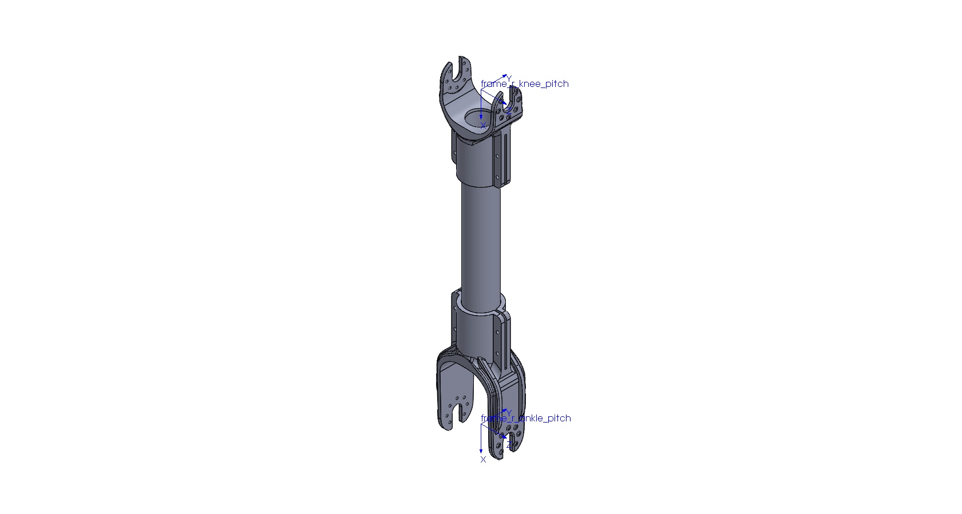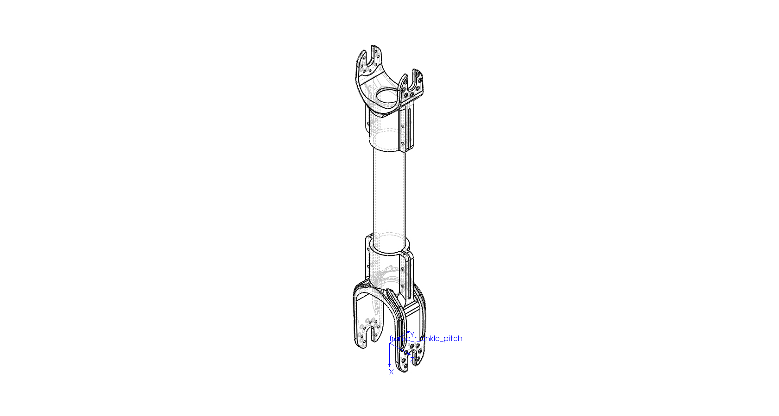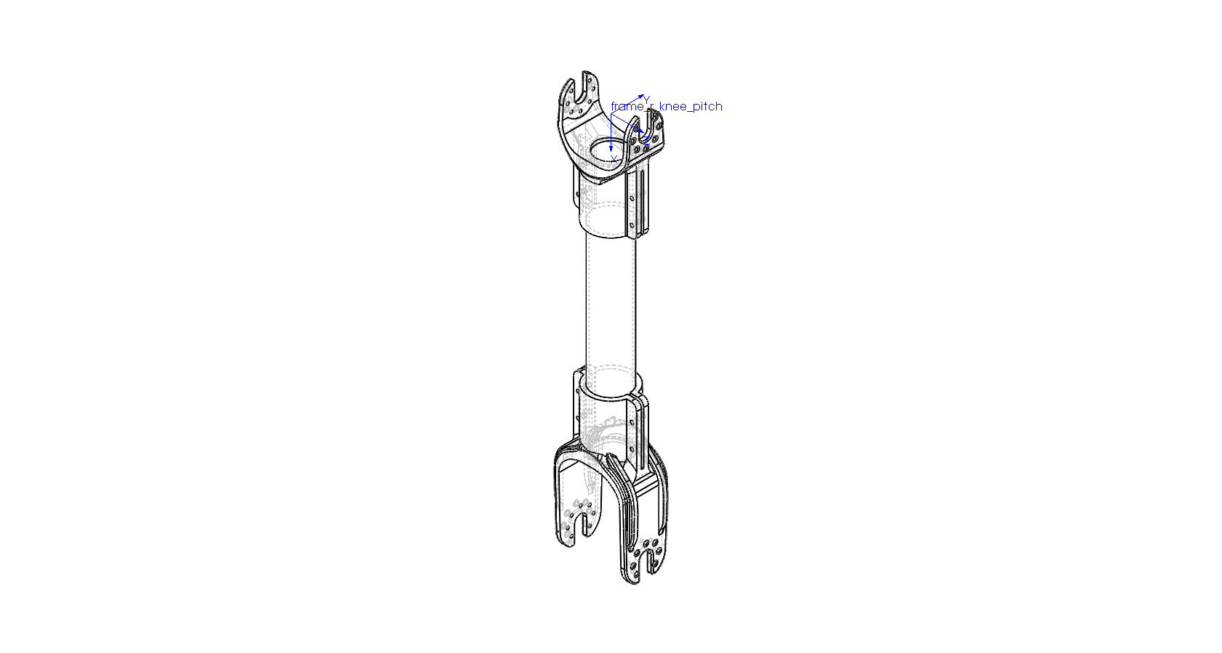

# URDF Convention

| Link | Frame | Mass [kg] | Center of mass [m] | | |
| --- | --- | --- | --- | --- | --- |
| X | Y | Z |
| R Knee Pitch | frame_r_knee_pitch | 0.15100000 | 0.16288218 | 0.00000000 | 0.00000000 |

| Link | Moments of Inertia [kg*m^2] (Taken at the center of mass) | | | | | |
| --- | --- | --- | --- | --- | --- | --- |
| Ixx | Ixy | Ixz | Iyy | Iyz | Izz |
| R Knee Pitch | 0.00006340 | 0.00000000 | 0.00000000 | 0.00139612 | 0.00000000 | 0.00136731 |

# DH convention

| Link | Frame | Mass [kg] | Center of mass [m] | | |
| --- | --- | --- | --- | --- | --- |
| X | Y | Z |
| R Knee Pitch | frame_r_ankle_pitch | 0.15100000 | -0.15211782 | 0.00000000 | 0.00000000 |

| Link | Moments of Inertia [kg*m^2] (Taken at the center of mass) | | | | | |
| --- | --- | --- | --- | --- | --- | --- |
| Ixx | Ixy | Ixz | Iyy | Iyz | Izz |
| R Knee Pitch | 0.00006340 | 0.00000000 | 0.00000000 | 0.00139612 | 0.00000000 | 0.00136731 |

## RIGHT LEG -> ankle pitch

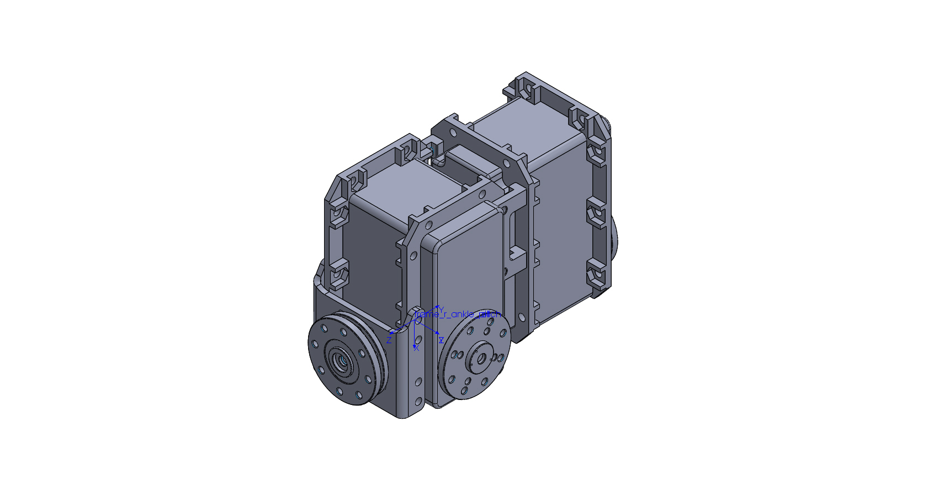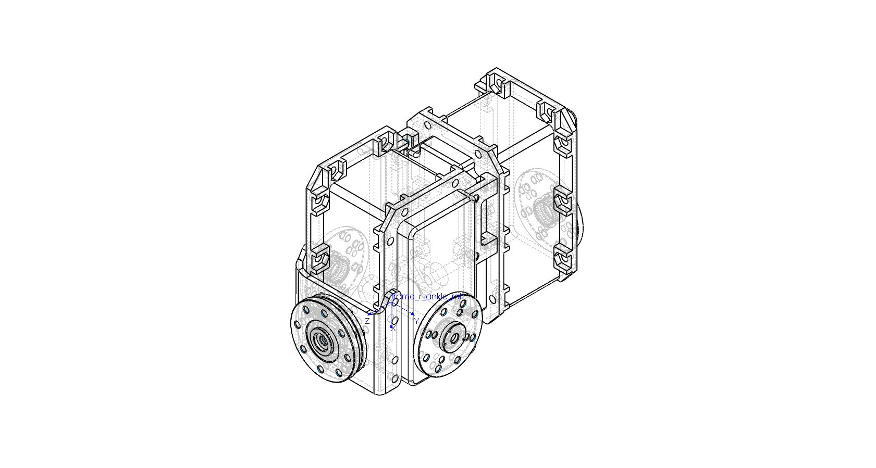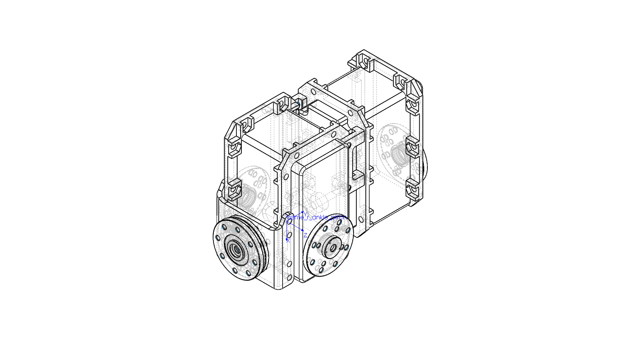

# URDF Convention

| Link | Frame | Mass [kg] | Center of mass [m] | | |
| --- | --- | --- | --- | --- | --- |
| X | Y | Z |
| R Ankle Pitch | frame_r_ankle_pitch | 0.34300000 | -0.01526210 | 0.02152545 | 0.00000000 |

| Link | Moments of Inertia [kg*m^2] (Taken at the center of mass) | | | | | |
| --- | --- | --- | --- | --- | --- | --- |
| Ixx | Ixy | Ixz | Iyy | Iyz | Izz |
| R Ankle Pitch | 0.00026847 | -0.00000219 | -0.00000081 | 0.00014760 | 0.00000000 | 0.00032449 |

# DH convention

| Link | Frame | Mass [kg] | Center of mass [m] | | |
| --- | --- | --- | --- | --- | --- |
| X | Y | Z |
| R Ankle Pitch | frame_r_ankle_roll | 0.34300000 | -0.01526210 | 0.00000000 | -0.02152545 |

| Link | Moments of Inertia [kg*m^2] (Taken at the center of mass) | | | | | |
| --- | --- | --- | --- | --- | --- | --- |
| Ixx | Ixy | Ixz | Iyy | Iyz | Izz |
| R Ankle Pitch | 0.00026847 | -0.00000081 | 0.00000219 | 0.00032449 | 0.00000000 | 0.00014760 |

## RIGHT LEG -> ankle roll

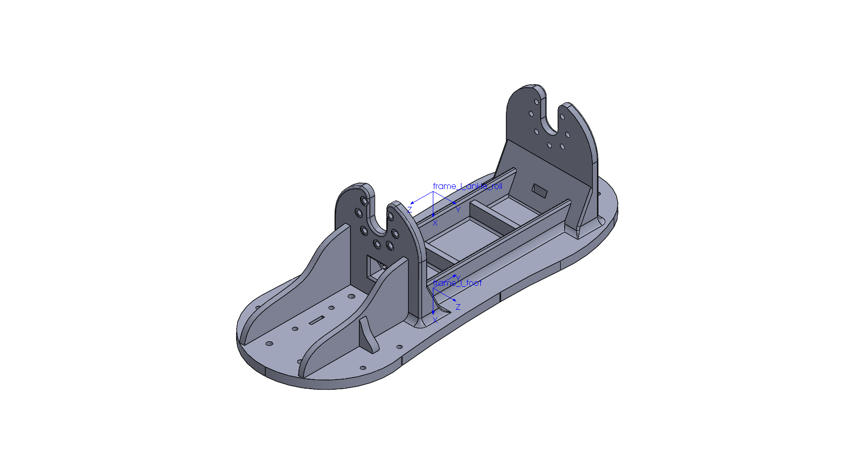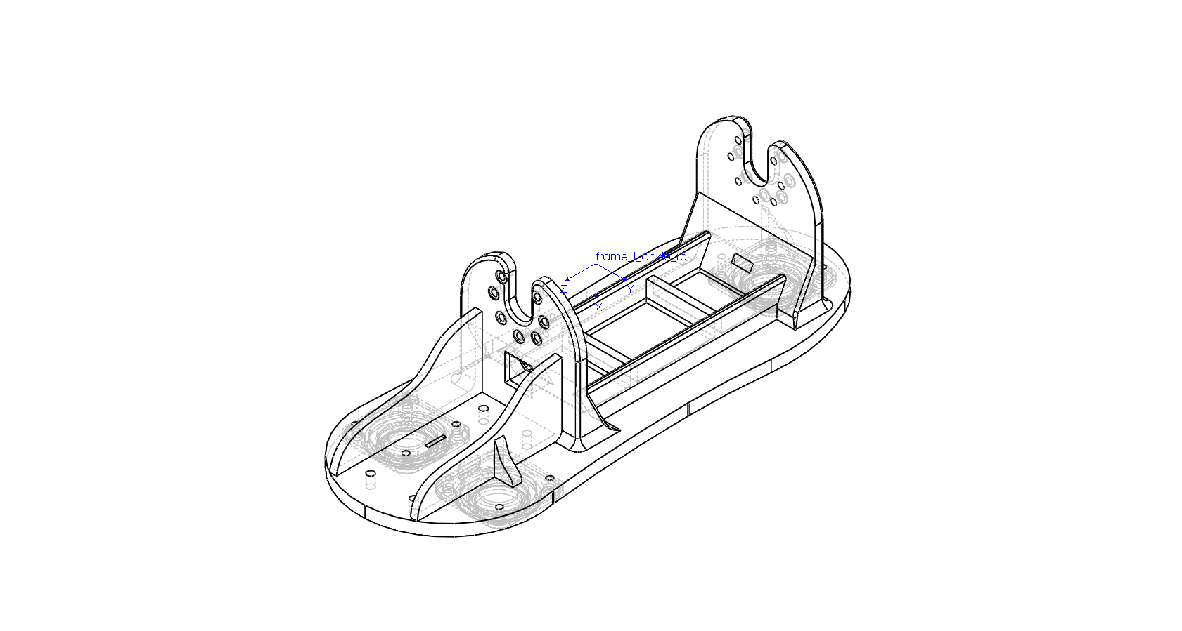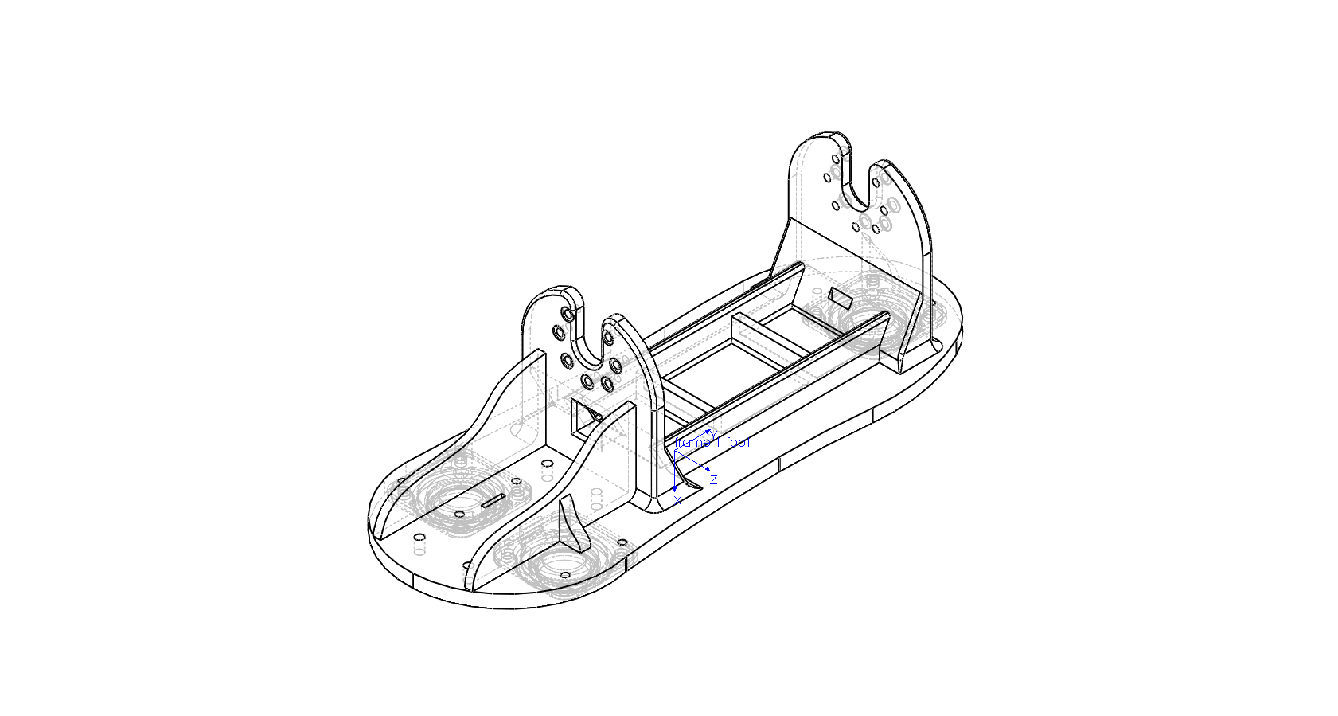

# URDF Convention

| Link | Frame | Mass [kg] | Center of mass [m] | | |
| --- | --- | --- | --- | --- | --- |
| X | Y | Z |
| R Ankle Roll | frame_r_ankle_roll | 0.10500000 | 0.03625882 | -0.00019548 | 0.00034576 |

| Link | Moments of Inertia [kg*m^2] (Taken at the center of mass) | | | | | |
| --- | --- | --- | --- | --- | --- | --- |
| Ixx | Ixy | Ixz | Iyy | Iyz | Izz |
| R Ankle Roll | 0.00034591 | -0.00000013 | 0.00000857 | 0.00032705 | 0.00000120 | 0.00004813 |

# DH convention

| Link | Frame | Mass [kg] | Center of mass [m] | | |
| --- | --- | --- | --- | --- | --- |
| X | Y | Z |
| R Ankle Roll | frame_r_foot | 0.10500000 | -0.01454118 | -0.00034576 | -0.00019548 |

| Link | Moments of Inertia [kg*m^2] (Taken at the center of mass) | | | | | |
| --- | --- | --- | --- | --- | --- | --- |
| Ixx | Ixy | Ixz | Iyy | Iyz | Izz |
| R Ankle Roll | 0.00034591 | -0.00000857 | -0.00000013 | 0.00004813 | -0.00000120 | 0.00032705 |

## left LEG -> Hip yaw

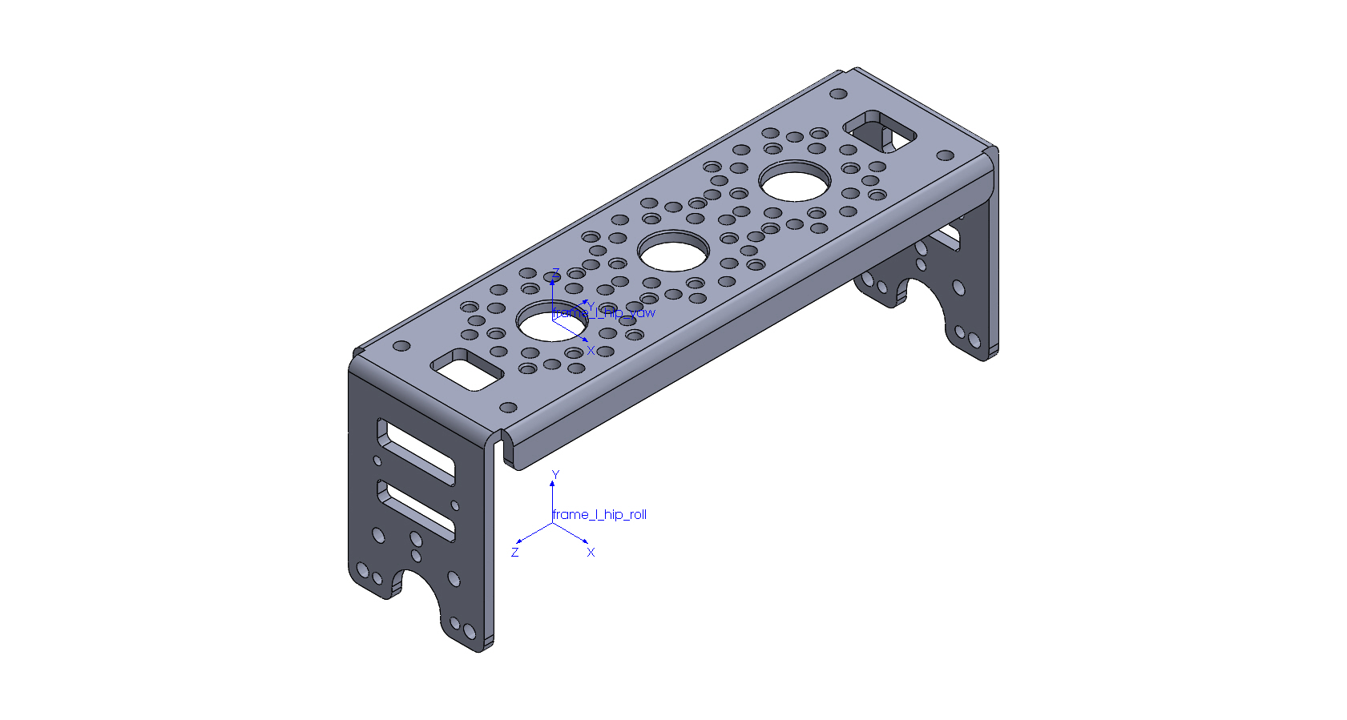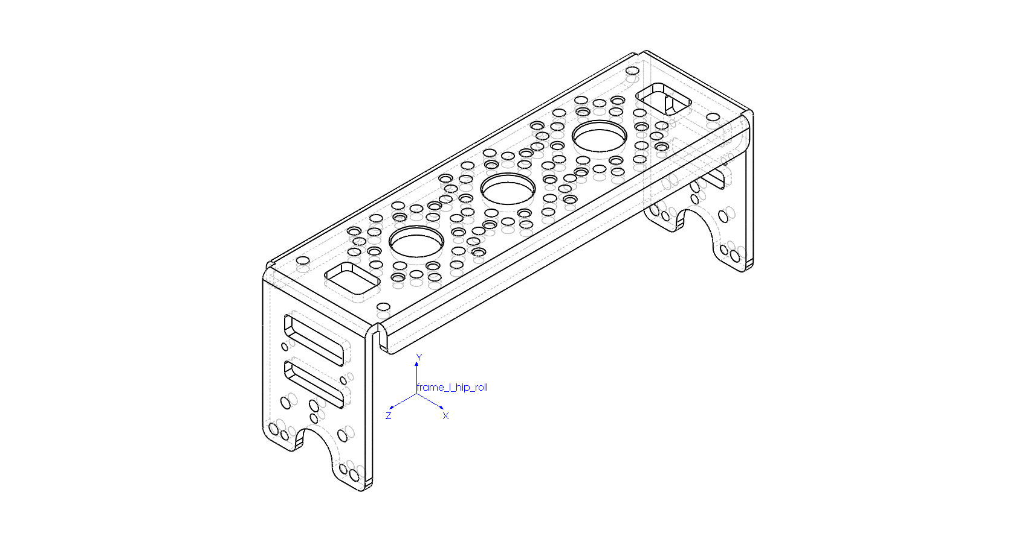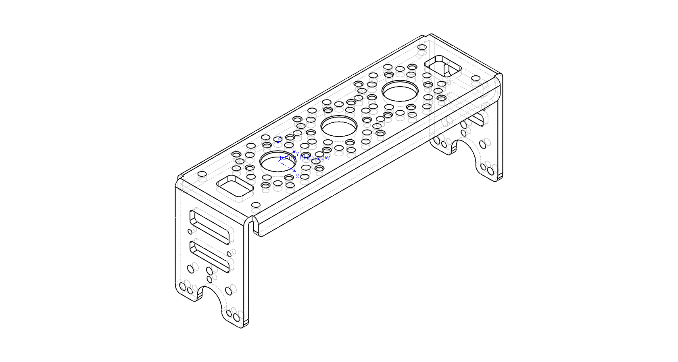

# URDF Convention

| Link | Frame | Mass [kg] | Center of mass [m] | | |
| --- | --- | --- | --- | --- | --- |
| X | Y | Z |
| L Hip Yaw | frame_l_hip_yaw | 0.09100000 | 0.00000000 | 0.02500000 | -0.00735017 |

| Link | Moments of Inertia [kg*m^2] (Taken at the center of mass) | | | | | |
| --- | --- | --- | --- | --- | --- | --- |
| Ixx | Ixy | Ixz | Iyy | Iyz | Izz |
| L Hip Yaw | 0.00014158 | 0.00000000 | 0.00000000 | 0.00002022 | 0.00000000 | 0.00014316 |

# DH convention

| Link | Frame | Mass [kg] | Center of mass [m] | | |
| --- | --- | --- | --- | --- | --- |
| X | Y | Z |
| L Hip Yaw | frame_l_hip_roll | 0.09100000 | 0.00000000 | 0.02864983 | -0.02500000 |

| Link | Moments of Inertia [kg*m^2] (Taken at the center of mass) | | | | | |
| --- | --- | --- | --- | --- | --- | --- |
| Ixx | Ixy | Ixz | Iyy | Iyz | Izz |
| L Hip Yaw | 0.00014158 | 0.00000000 | 0.00000000 | 0.00014316 | 0.00000000 | 0.00002022 |

## left LEG -> Hip roll



# URDF Convention

| Link | Frame | Mass [kg] | Center of mass [m] | | |
| --- | --- | --- | --- | --- | --- |
| X | Y | Z |
| L Hip Roll | frame_l_hip_roll | 0.34300000 | 0.00000000 | -0.01526210 | -0.02652545 |

| Link | Moments of Inertia [kg*m^2] (Taken at the center of mass) | | | | | |
| --- | --- | --- | --- | --- | --- | --- |
| Ixx | Ixy | Ixz | Iyy | Iyz | Izz |
| L Hip Roll | 0.00032449 | -0.00000081 | 0.00000000 | 0.00026847 | 0.00000219 | 0.00014760 |

# DH convention

| Link | Frame | Mass [kg] | Center of mass [m] | | |
| --- | --- | --- | --- | --- | --- |
| X | Y | Z |
| L Hip Roll | frame_l_hip_pitch | 0.34300000 | 0.01526210 | 0.02152545 | 0.00000000 |

| Link | Moments of Inertia [kg*m^2] (Taken at the center of mass) | | | | | |
| --- | --- | --- | --- | --- | --- | --- |
| Ixx | Ixy | Ixz | Iyy | Iyz | Izz |
| L Hip Roll | 0.00026847 | 0.00000219 | 0.00000081 | 0.00014760 | 0.00000000 | 0.00032449 |

## left LEG -> Hip pitch

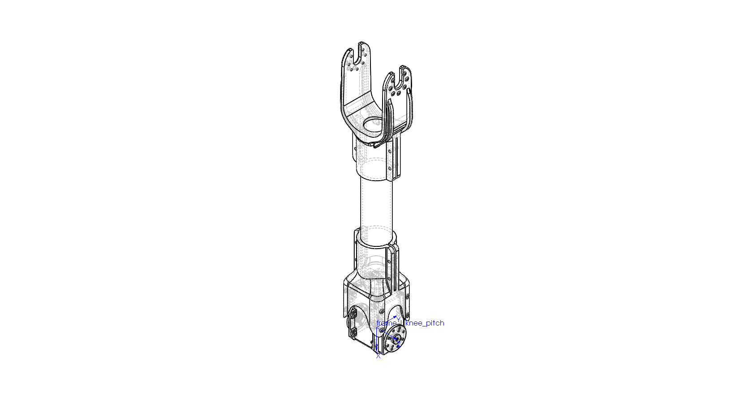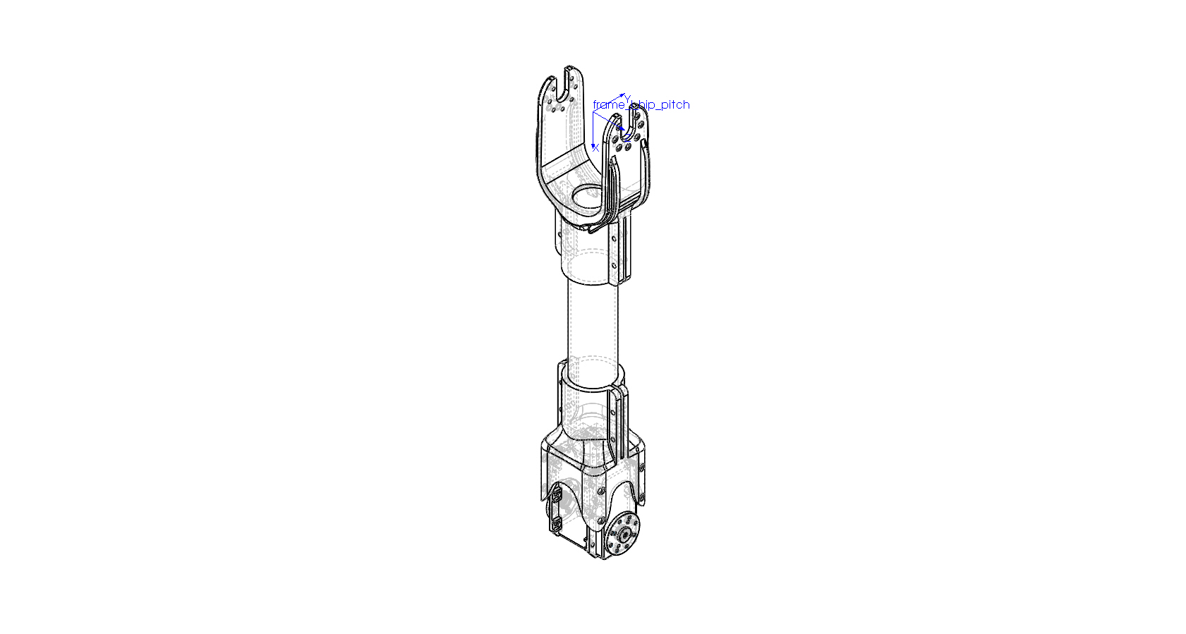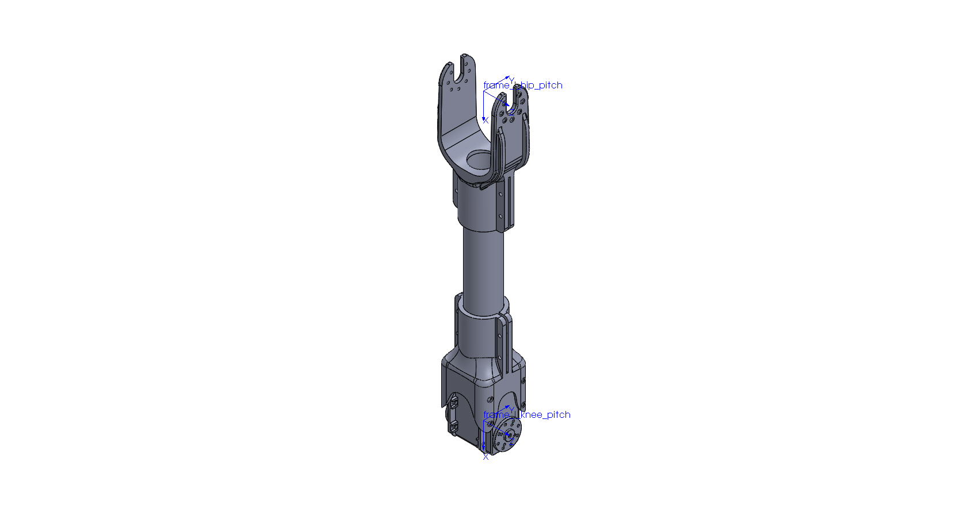

# URDF Convention

| Link | Frame | Mass [kg] | Center of mass [m] | | |
| --- | --- | --- | --- | --- | --- |
| X | Y | Z |
| L Hip Pitch | frame_l_hip_pitch | 0.31800000 | 0.22137989 | 0.00000000 | 0.00000000 |

| Link | Moments of Inertia [kg*m^2] (Taken at the center of mass) | | | | | |
| --- | --- | --- | --- | --- | --- | --- |
| Ixx | Ixy | Ixz | Iyy | Iyz | Izz |
| L Hip Pitch | 0.00011525 | 0.00000000 | 0.00000078 | 0.00254669 | 0.00000000 | 0.00250848 |

# DH convention

| Link | Frame | Mass [kg] | Center of mass [m] | | |
| --- | --- | --- | --- | --- | --- |
| X | Y | Z |
| L Hip Pitch | frame_l_knee_pitch | 0.31800000 | -0.07862011 | 0.00000000 | 0.00000000 |

| Link | Moments of Inertia [kg*m^2] (Taken at the center of mass) | | | | | |
| --- | --- | --- | --- | --- | --- | --- |
| Ixx | Ixy | Ixz | Iyy | Iyz | Izz |
| L Hip Pitch | 0.00011525 | 0.00000000 | 0.00000078 | 0.00254669 | 0.00000000 | 0.00250848 |

## left LEG -> Knee pitch

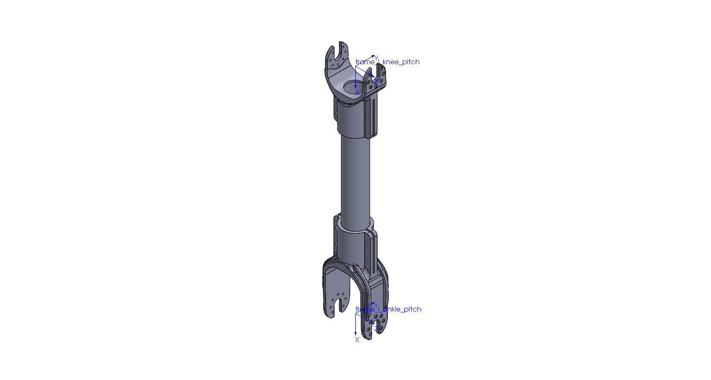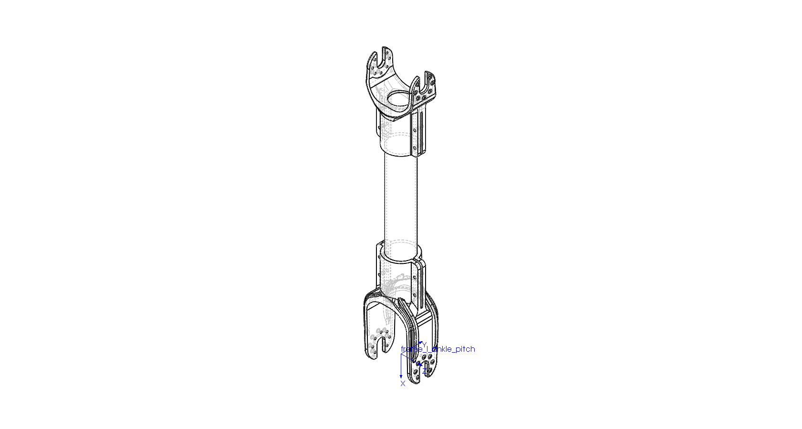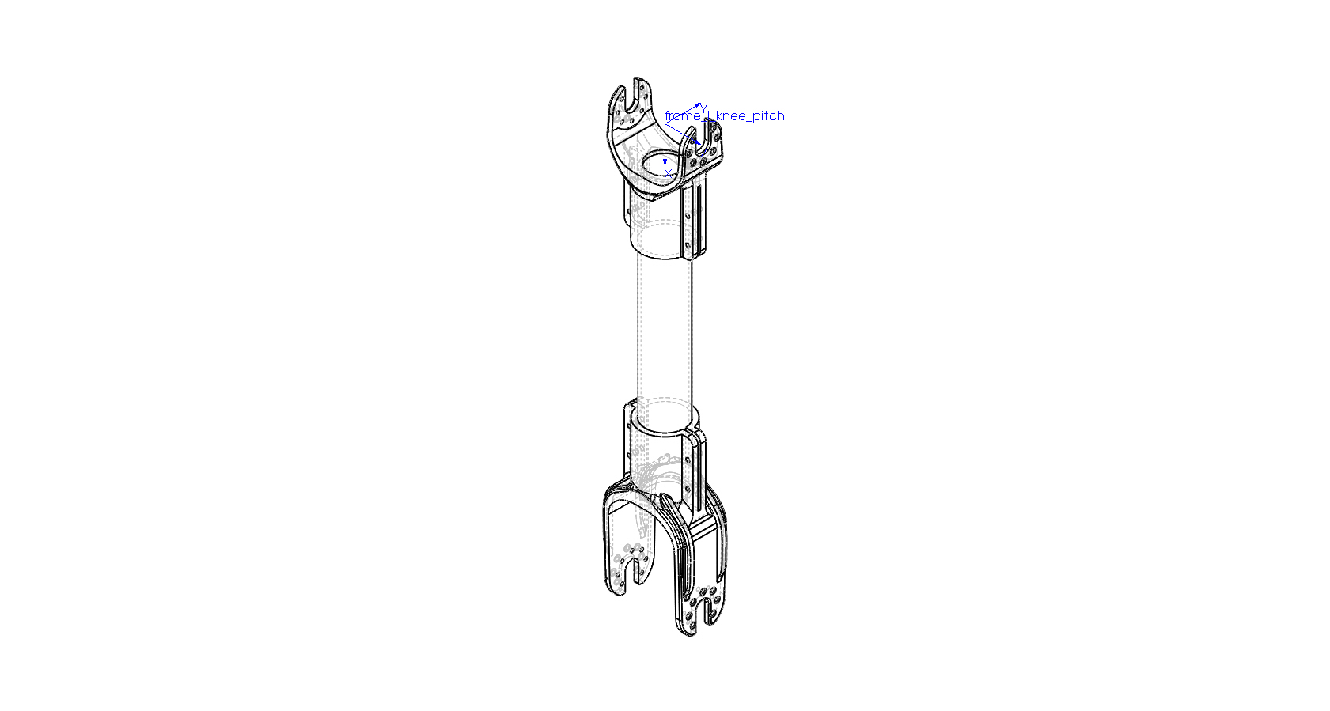

# URDF Convention

| Link | Frame | Mass [kg] | Center of mass [m] | | |
| --- | --- | --- | --- | --- | --- |
| X | Y | Z |
| L Knee Pitch | frame_l_knee_pitch | 0.15100000 | 0.16288218 | 0.00000000 | 0.00000000 |

| Link | Moments of Inertia [kg*m^2] (Taken at the center of mass) | | | | | |
| --- | --- | --- | --- | --- | --- | --- |
| Ixx | Ixy | Ixz | Iyy | Iyz | Izz |
| L Knee Pitch | 0.00006340 | 0.00000000 | 0.00000000 | 0.00139612 | 0.00000000 | 0.00136731 |

# DH convention

| Link | Frame | Mass [kg] | Center of mass [m] | | |
| --- | --- | --- | --- | --- | --- |
| X | Y | Z |
| L Knee Pitch | frame_l_ankle_pitch | 0.15100000 | -0.15211782 | 0.00000000 | 0.00000000 |

| Link | Moments of Inertia [kg*m^2] (Taken at the center of mass) | | | | | |
| --- | --- | --- | --- | --- | --- | --- |
| Ixx | Ixy | Ixz | Iyy | Iyz | Izz |
| L Knee Pitch | 0.00006340 | 0.00000000 | 0.00000000 | 0.00139612 | 0.00000000 | 0.00136731 |

## left LEG -> ankle pitch

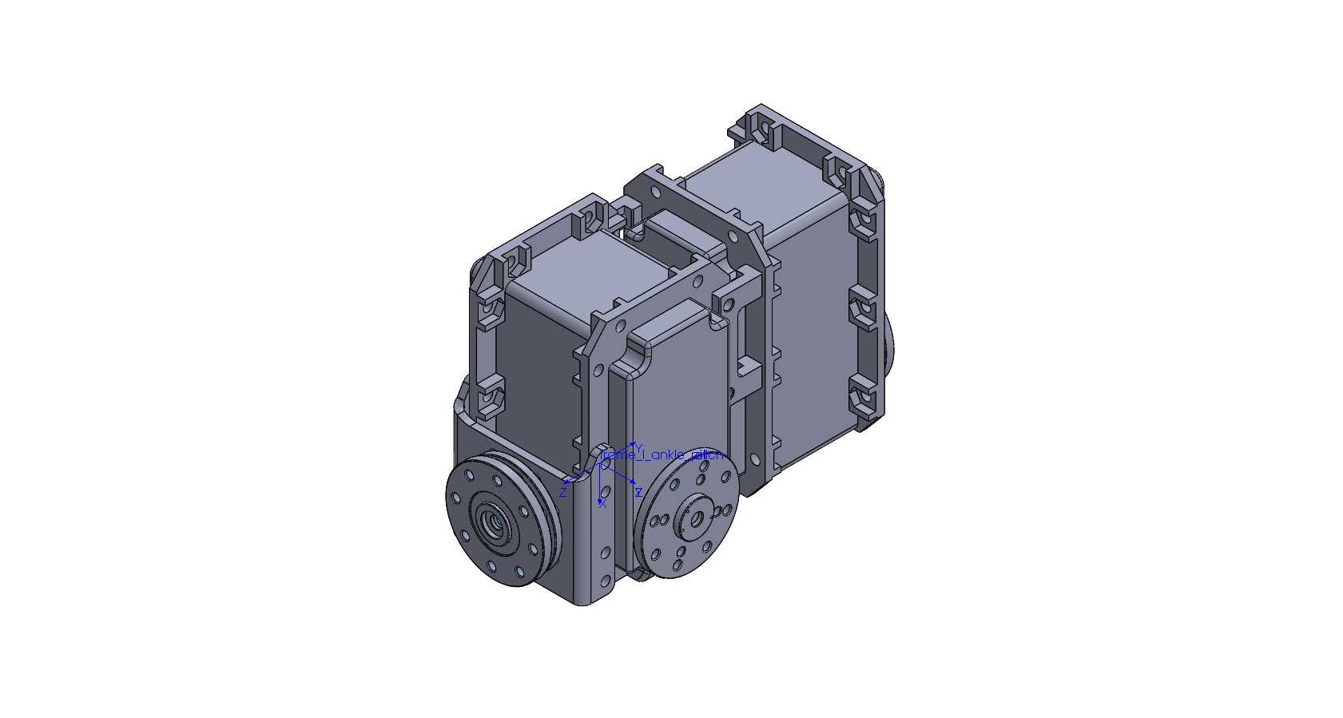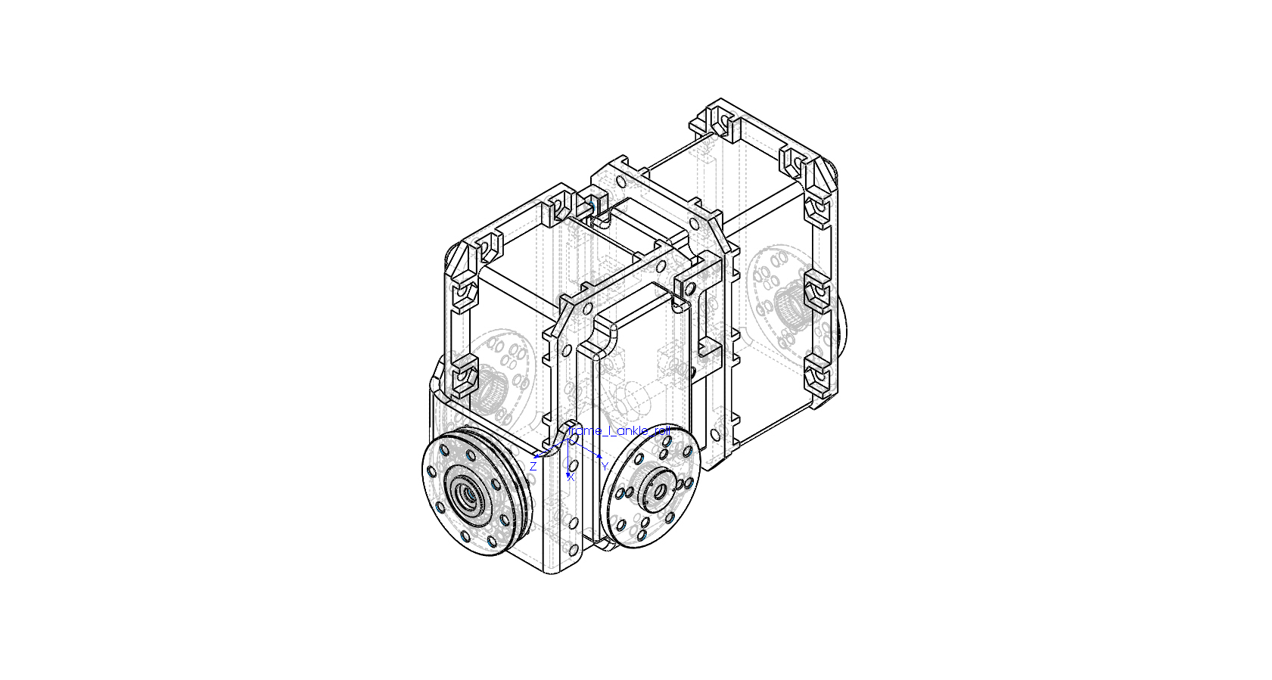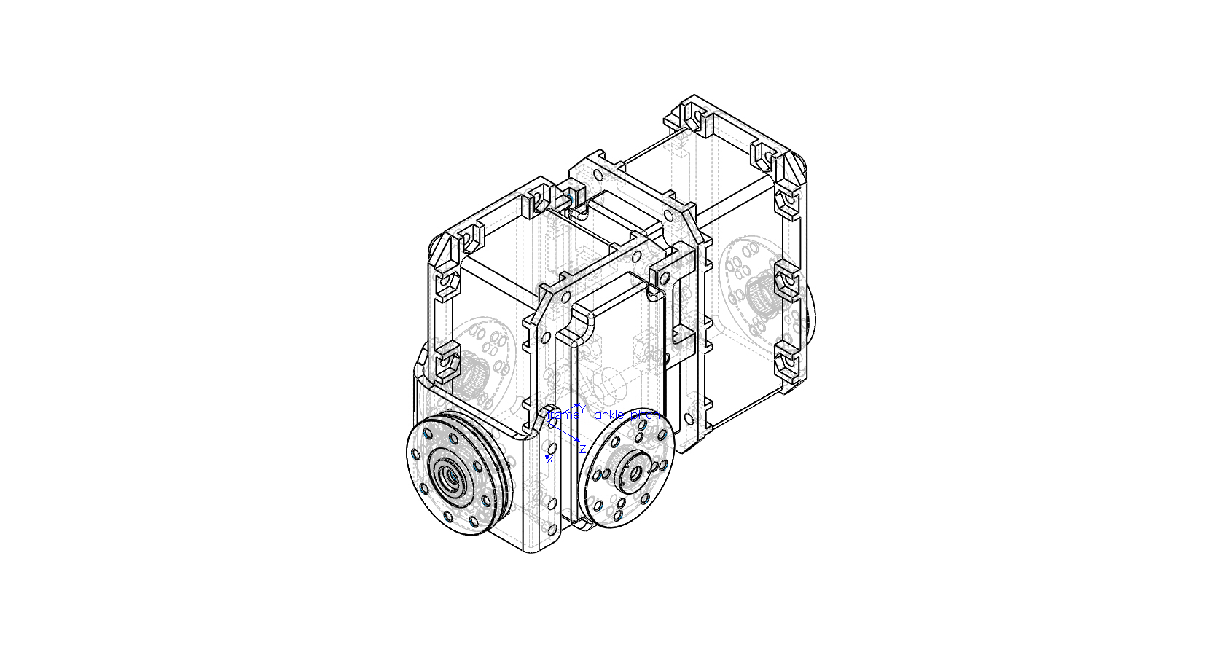

# URDF Convention

| Link | Frame | Mass [kg] | Center of mass [m] | | |
| --- | --- | --- | --- | --- | --- |
| X | Y | Z |
| L Ankle Pitch | frame_l_ankle_pitch | 0.34300000 | -0.01526210 | 0.02152545 | 0.00000000 |

| Link | Moments of Inertia [kg*m^2] (Taken at the center of mass) | | | | | |
| --- | --- | --- | --- | --- | --- | --- |
| Ixx | Ixy | Ixz | Iyy | Iyz | Izz |
| L Ankle Pitch | 0.00026847 | -0.00000219 | -0.00000081 | 0.00014760 | 0.00000000 | 0.00032449 |

# DH convention

| Link | Frame | Mass [kg] | Center of mass [m] | | |
| --- | --- | --- | --- | --- | --- |
| X | Y | Z |
| L Ankle Pitch | frame_l_ankle_roll | 0.34300000 | -0.01526210 | 0.00000000 | -0.02152545 |

| Link | Moments of Inertia [kg*m^2] (Taken at the center of mass) | | | | | |
| --- | --- | --- | --- | --- | --- | --- |
| Ixx | Ixy | Ixz | Iyy | Iyz | Izz |
| L Ankle Pitch | 0.00026847 | -0.00000081 | 0.00000219 | 0.00032449 | 0.00000000 | 0.00014760 |

## left LEG -> ankle roll



# URDF Convention

| Link | Frame | Mass [kg] | Center of mass [m] | | |
| --- | --- | --- | --- | --- | --- |
| X | Y | Z |
| L Ankle Roll | frame_l_ankle_roll | 0.10500000 | 0.03608455 | 0.00020160 | 0.00002697 |

| Link | Moments of Inertia [kg*m^2] (Taken at the center of mass) | | | | | |
| --- | --- | --- | --- | --- | --- | --- |
| Ixx | Ixy | Ixz | Iyy | Iyz | Izz |
| L Ankle Roll | 0.00034223 | 0.00000014 | 0.00000840 | 0.00032348 | -0.00000118 | 0.00004816 |

# DH convention

| Link | Frame | Mass [kg] | Center of mass [m] | | |
| --- | --- | --- | --- | --- | --- |
| X | Y | Z |
| L Ankle Roll | frame_l_foot | 0.10500000 | -0.01471545 | -0.00002697 | 0.00020160 |

| Link | Moments of Inertia [kg*m^2] (Taken at the center of mass) | | | | | |
| --- | --- | --- | --- | --- | --- | --- |
| Ixx | Ixy | Ixz | Iyy | Iyz | Izz |
| L Ankle Roll | 0.00034223 | -0.00000840 | 0.00000014 | 0.00004816 | 0.00000118 | 0.00032348 |

## 